Application of Cognitive Theory in
Multimedia Technology Based Learning: Concentration on Malaysian Cultural
and Heritage
Ng Perng Jeu
Department of Multimedia Design & Animation
Universiti Tunku Abdul Rahman
Petaling Jaya, Malaysia.
Mohd Fairuz bin Ali
Department of Multimedia Design & Animation
Universiti Tunku Abdul Rahman
Petaling Jaya, Malaysia.
Aloysius Yapp
Department of Multimedia Design & Animation
Universiti Tunku Abdul Rahman
Petaling Jaya, Malaysia.

Abstract — This study established on developing the educational technology as a tool in improving learning performance when used in education. The hypothesis is based on cognitive theory of multimedia learning which suggests that presenting the teaching materials in a form of interactive Multimedia could enhance the learning experience. The research suggests that the interactive multimedia elements applied in the educational technology can enhance the learning process by helping to improve the ability and levels of motivation of receiving the information related to Malaysian culture of Malaysian language, Malaysian traditional game Wau and Panglima Bukit Sadok.

Keywords — Malaysian traditional game, animation, multimedia instruction, computer digital game, edutainment

Introduction
In multimedia learning, information is presented to students with a combination of different modalities or modes such as spoken words and pictures. Mode refers to the format used to represent the lesson, such as words versus pictures. Modality refers to the information-processing channel used by the learner to process the information, such as auditory versus visual.
However, Kalyuga et al.[1] suggested that some multimedia learning software can lead to cognitive overload, which affects learning performance negatively. The purpose of instructional design is to assist learners to store information in long term memory. This implies that the way teaching materials presented to learners is a key element in instructional design. Attention to cognitive load is a critical concern for instructional designers when designing multimedia teaching materials, because unnecessary multimedia messages may worsen learning performance by increasing working memory load and interrupting information processing.
The massive influence has created a new pop culture which provides unlimited volumes of variety interactive multimedia applications available as to date. The mushrooming of computer technologies media that have been incorporated with learning tools are designed competitively in almost all type of area such as 2D Animation, 3D Animation, Computer digital game, Mobile phone applications and many more.

Context
Multimedia instructional systems have been widely applied in teaching and learning, but the media presentation mode that is best for English listening comprehension remains uncertain, and whether unnecessary information leading to cognitive overload for the learners also remains inconclusive. According to the studies done by Jones and etc [2], Diao and etc[3], students who learn with double mode (sound and text) outperformed students who learn with single mode (sound) and had lower cognitive load. Studies related to foreign language learning and cognitive load are mostly about digital learning environments. Besides that, scholars, researchers, and game developers have written countless of scholarly and non-scholarly articles on how multimedia learning based can be a sufficient instrument as social agent to inculcate a sense of formal and informal learning context, Staalduinen and etc [4] discovered a new wavelength in the edutainment industry. Specifically, the purposes of this study are as the following:
- To explore on Malaysian identity contents that have been incorporated with interactive multimedia technology by using three Malaysian identities that have designed previously which are (1) Interactive Multimedia Courseware: Malaysian Language (Bahasa); (2) Computer Digital Game: Malaysian traditional game (Wau); and (3) 2D Digital Animation Borneo: Local Legendary Identity (Warrior of Sadok Hill); and
- To provide on the process of each interactive multimedia technology as stated above and its effectiveness. .

Procedure Of The Study
(i) Malaysian Language
In language learning experimental, one hundred and eight standard three students in public primary Chinese school made up the sample for this study. All students had attended Bahasa Melayu class and had some basic understanding on different type of nouns. Participants are randomly assigned to two conditions with different versions of learning mode, 54 students had to learn with sound narration and animation (modality learning mode) and 54 students had to learn with sound narration , animation and on screen text (redundancy learning group). Students will be assigned to computer laboratories that could accommodate an entire class of up to 25 students at one time.
This experiment was conducted in a computer-based learning environment. All students took part in the experiment. This study is an experimental design with independent measures. The independent variables were the learning modes (redundancy group and modality group). The dependent variables were gender (male and female students) and the motivation towards the instructional modes (as measured by Keller’s IMMS questionnaire). This experimental were using a one-way ANOVA to analyze the interaction between the dependent variables on the dependent variable.
(a) Pretest Phase
A prior knowledge test was administrated to determine the participants’ prior knowledge of the topic of nouns. This pretest contained 14 questions.

(b) Intervention Phase
Immediately after the students had completed the pretest; they were given the version of the presentation mode that corresponded to the experimental condition they were assigned to. Students in all the two presentation modes were exposed to the same instructional materials but in different modes of presentation. Students in the redundancy mode were asked to learn the nouns by watching the short animation (illustration, narration and on-screen text) on the computer. The learning environment for the students in the modality mode was exactly the same as redundancy mode, except the animation content on the computer only consisted of illustration and narration. Students can control the presentation of the computer-based learning material by using computer’s mouse.

(c) Post Test
Immediately after the students completed the learning activity, they were asked to complete a test to assess their understanding of nouns. This posttest contained 15 questions.
There were two instruments in this study, (i) the Bahasa Melayu nouns pre-test and post test questions (each comprising of 14 questions and 15 questions from the domain of understanding and distinguish the type of nouns), and (ii) the Instructional Material Motivation Scale (IMMS) to measure the learners’ motivation towards the learning modes. The Instructional Material Motivation Scale (IMMS) was developed by Keller [5] to measure the learners’ motivation towards the modes of instruction. In this study, the original Likert-type choices will be changed to emoticon which is much more suitable for students. The IMMS questionnaire will be comprised of 36 emoticon statements (adapted version) that are based on four components of ARCS model: Attention, Relevance, Confidence and Satisfaction.

(ii) Malaysian Traditional Game “Wau”
In digital game ‘Wau’ research activities, Mixed methods were used in conducting this research using four different stages – (i) Data gathering and collection by distributing 100 questionnaires with 66 respondents responded from Segi College University (30 respondents) and University of Selangor (UNISEL) students (36 respondents) respectively to test their general knowledge on Wau with no access of playing the game on computer. (ii) A pretest is administered at Segi College University Kota Damansara with 20 respondents. (iii) Posttest was conducted at UNISEL with 26 respondents. The idea of conducting in two different universities were not to compare the respondents playing skills and understanding level of the game rather the limited access to the university and computer lab has pushed researcher to find another location to conduct the gameplay with the small number of respondents. University students were chosen as focus group in this research as they represent the mediocre views in between adults and younger generation. In the pretest and posttest, different respondents were given the same set of questionnaires to analyze their attitudinal changes toward Wau computer game. The questions were distributed to the respondents upon the completion of the Wau game to Level 2.

(iii) 2D Digital Animation Borneo: Local Legendary Identity (Warrior of Sadok Hill)
The researchers used random sampling methods in river Saribas, Entanak up to Saka .With the information obtained. Other than on their own efforts, the researchers used school boy as research assistant to collect information from their respective long houses. After obtaining the information from a variety of sources from respondents, the researchers used qualitative methods to interpret these data. The finding of the various data acquired new status quo. The information is generated based on the opinion of three rivers. This is the area that witnessed the war of freedom launched by PBS towards Brooke regime in 1860’s. Next the researchers will use the information which has been interpreted to be the initial framework for creation of PBS synopsis construction. After the character design, background and screen breakdown, the researcher proceeds with the stage which looking into the production of storyboarding. In the visualization process, the researchers obtained the original drawing and PBS

Results
The goals of this experiment were to investigate (i) the effects of cognitive theory of multimedia learning on the learning of Bahasa Malaysia as second language among primary Chinese school students; (ii) application on edutainment as a game based learning for students and (iii) the 2D animation learning.
.
RESULT 1: COMPARISON ON THE LEARNING OUTCOME BASED ON REDUNDANCY AND MODALITY LEARNING MODE

Table 1 presents the number of learners, means of IMMS score, standard deviations and standard errors for male and female students in the two learning modes (redundancy and modality). Values of standard deviations for learners in redundancy learning mode and modality learning mode were (SD = 4.953) and (SD = 6.735) respectively. That means that genders in learning mode had a mean effect on the IMMS score. Female students (mean = 124.888, SD= 4.492, p=0. 000) significantly more motivated than male students in the redundancy learning mode.

- Number Of Learners, Means, Standard Deviations And Standard Error Of IMMS Score And Gender By Learning Mode
Redundancy Learning Mode
Gender | IMMS Score
 | N | M | SD | SE
Male | 27 | 106.370 | 5.414 | 1.042
Female | 27 | 124.888 | 4.492 | 0.864
Total | 54 | 115.629 | 4.953 | 0.953
Modality Learning Mode
Gender | IMMS Score
 | N | M | SD | SE
Male | 27 | 111.481 | 5.308 | 1.021
Female | 27 | 105.037 | 6.536 | 1.258
Total | 54 | 108.259 | 6.735 | 0.961


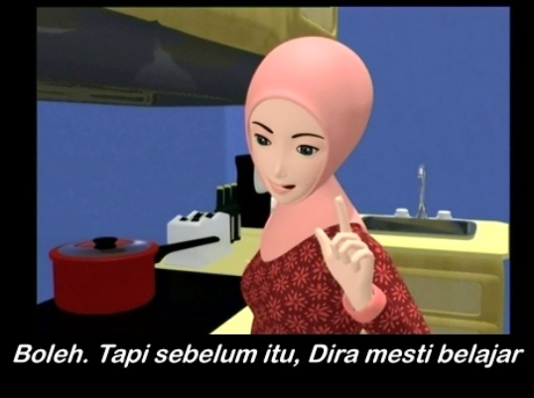
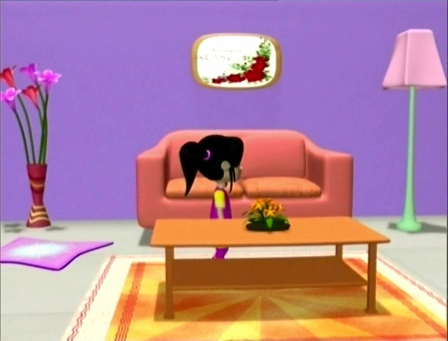
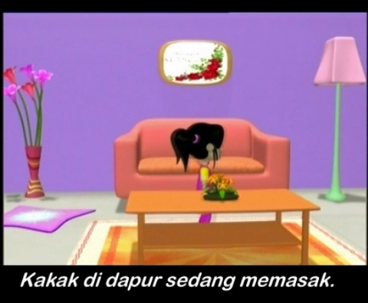
Modality Learning Mode Redundancy Learning Mode

Fig. 1. Example of screen caption on multimedia instruction.

RESULT 2: INVESTIGATION RESULT ON STUDENTS ATTITUDE TOWARDS LEARNING TRADITIONAL GAME IN EDUCATIONAL GAME BY COMPUTER

The Posttest was conducted at University Selangor (UNISEL) with 26 respondents participated in a computer lab. The same method used in Pretest is applied in the Posttest with the distribution of same questionnaires toward the end of the game. Twenty two respondents (84.6%) were able to complete both levels. Only one respondent was having a problem while playing the game. Eight respondents (30.8%) found that Level 2 was not easy to accomplish, while 4 respondents (15.4%) felt that the music was too loud. Similar with the response in the Pretest, majority of the respondents found that the characters design were suitable and attractive, the background, choice of music and sound effects are suitable with 26 respondents (100%) gave a positive feedback that the game is able to educate people on Wau. Researcher took immediate action by reducing the music volume to an average level of acceptance.
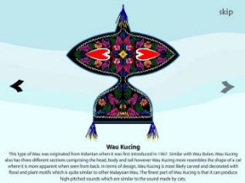
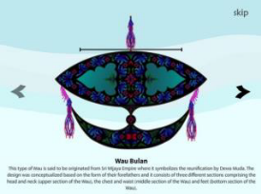
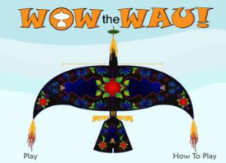
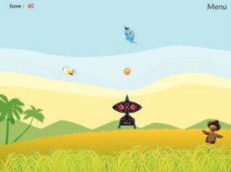

Fig. 2. Screen captures of Wow the Wau! Game

RESULT 3: APPLYING THE THEORY OF FIDELITY IN PRODUCE VISUAL ART

Through the adaptation theory of Fidelity of transformation, it is very important to practice give-and-take method. The Art element get involved are those line, dots, shape, form and texture. The combination of art elements creates an atmosphere which includes the outcome of the authentically local form and shape. Dots and line formed the texture in between the form and shape. The status quo is localization character with originality constricted visual setting. The principles of design such as balance, contrast, emphasis been carried lot of weight to delivered the design based visual construction. From the outcome of formation of form and shape, balancing point is the most important factor before the other principles [6]. By using Exaggeration as the principle to construct the character, lot more to study from the figure construction until the poses or gesture.

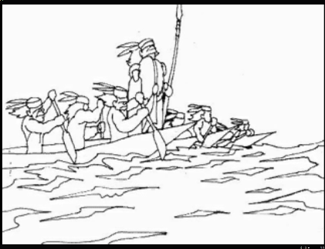

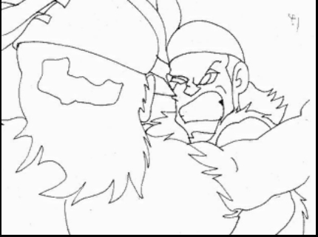
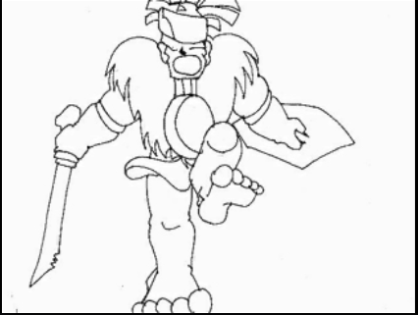

Fig. 3. Screen capture of PBS 2D animation

Conclusions
This study has shown that the applying of cognitive theory of multimedia learning in language learning courseware, computer based game learning, and new media visual presentation have positive outcome and intend on helping to improve the learning process and students’ performance. For future research, the test questions can be designed based on the content of instructional multimedia and it can directly measure the performance and test whether the design principle really fulfill the existing teaching material. It is suggested, future research can be executed covering Malaysian culture and heritage in a form of new media.

Acknowledgment
Special thanks and deeper gratitude to Universiti Tunku Abdul Rahman (UTAR) for the opportunity and continuous support for us to conduct a research on Malaysia cultural. Finally, thank to our parents and family for their support and encouragement throughout this study.

References
- S. Kalyuga, P. Chandler, and J. Sweller, Incorporating learner experience into the design of multimedia instruction. Journal of Educational Psychology, 92, 2000, pp. 126-136.
- L. Jones, and J. Plass, Supporting listening comprehension and vocabulary acquisition in French with multimedia annotations. The Modern Language Journal, 86(4), 2002, pp. 546-561.
- Y. Diao, and J. Sweller, Redundancy in foreign language reading comprehension instruction: Concurrent written and spoken
presentations. Learning and Instruction, 17(1), 2007, pp. 78-88.
- Staalduinen, J. P. V. and Freitas, S. D. Chapter Three: A Game-Based Learning Framework: Linking Game Design and Learning Outcomes. (n.d.).
- J. M. Keller, Motivation design of instruction. In C. M. Reigeluth (Ed.), Instructional-design theories and models: An overview of their current status. Hillsdale, NJ: Lawrence Erlbaum Associates, 1983, pp. 383-434.
[6] Lasseter, John (July 1987). "Principles of
Traditional Animation applied to 3D Computer
Animation". ACM Computer Graphics 21 (4): pp.
35–44. doi:10.1145/37402.37407

